TC-VER-004
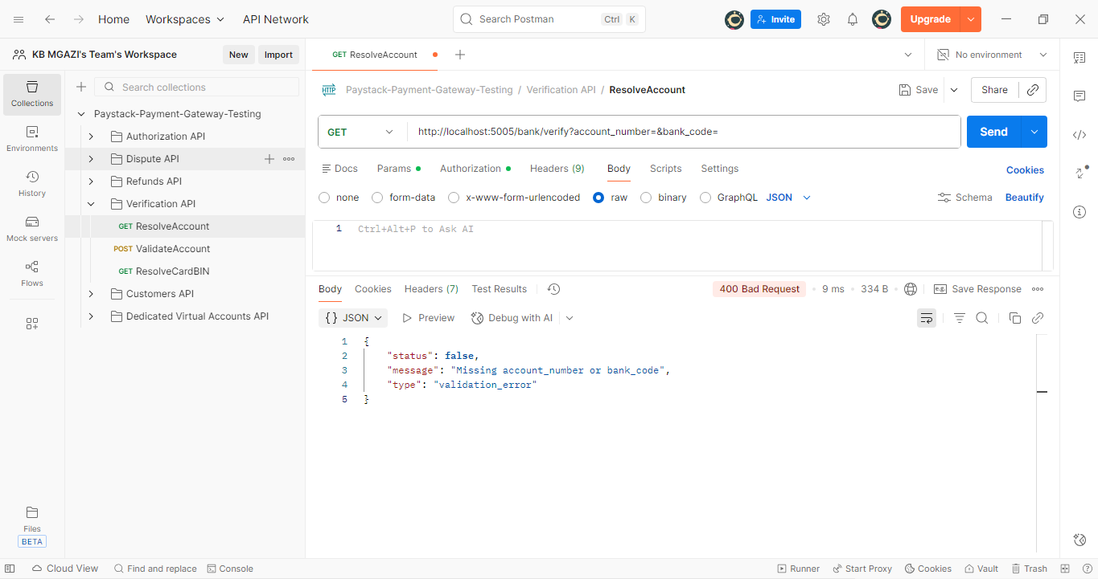
Response:
{
"status": false,
"message": "Missing account_number or bank_code",
"type": "validation_error"
}

